**Privacy consent**

Hey there!

We are a group of researchers who research human creativity. By participating in the "Spot the Spy" game, you consent to the collection and use of your gameplay data, including questions asked during the game, for research purposes. This data will be anonymized, aggregated, and securely stored.

If you will, please provide a few demographic details to help us further understand the diverse backgrounds of our participants. Rest assured that your personal identity will remain confidential and data will be accessed only by authorized researchers.

Thank you for your participation.

Demographic details: Age, country, years of education

**Instructions**

Welcome to "Spot the Spy"!

In a room full of people lies a sneaky spy in disguise, blending into the crowd while weaving a cloak of mystery around their true identity. Your mission is to uncover the hidden spy before they complete their covert mission and vanish without a trace, leaving chaos in their wake.

Use the chatbox in the bottom right corner of the screen to ask yes or no questions and get answers about the spy.



Right-click on a suspect to eliminate them as potential spies and blacken their character.

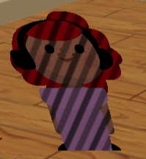

Double-click on a character to mark them as your prime suspect.

When you're ready, click the "MAKE GUESS" button to make your final guess.

If needed, press the Esc button at any time to stop the game.

Good luck on your quest, fellow agent. The room awaits your keen eye and strategic mind!